AD 741 Team 3 Assignment 4 - Solution Storming

(1) How do you begin to specifically map out and visualize the realization of your innovation?
You specifically begin to map out and visualize your innovation by identifying what the problem areas are and what are some workarounds that your target audience are dealing with. Once you have an idea of what the problem areas are you can begin to tailor the solution as a value proposition.

(2) What are the four types of prototypes from The Innovator’s Method?
The four types of prototypes from the Innovator’s Method are: 1. Theoretical Prototype, 2. Virtual prototype, 3. Minimum viable prototype, 4. Minimum awesome prototype. In the theoretical you are just expressed ideas and what you want the solution to be. The virtual prototypes are often nicknamed “pretend-otypes” to see if the solution is worth pursuing. The minimum viable prototypes are like beta tests that are released to learn crucial lessons about what customers actually want and confirm/deny your core assumptions. The minimum awesome prototype is an item or service that is so good that customers cannot resist and inspire positive emotion.

(3) What are your team ideas as shown in images for your Minimum Viable Prototype MVP and Minimum Awesome Product MAP?
For our MVP we would like to have the application with some rudimentary tabs to help discover, book, and track everything from flights to hotels to experiences. We would like to see if people are interested in having an all in one app to account for all things travel. Hopefully with the app we would like to have it easy to read and navigate.
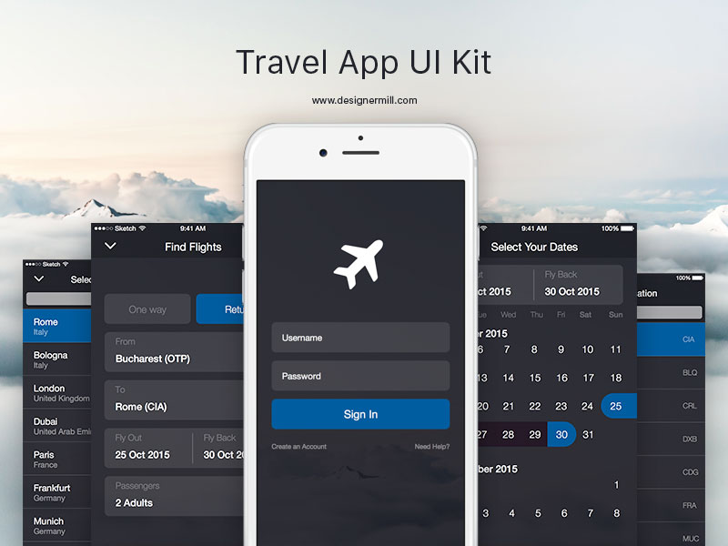

For our MAP we would like to have full integration with all airlines sign in so mobile boarding passes are quick to be able to be pulled up and have travel points logged. The MAP would likely have a few hundred excursions available with a wide network of tourism agencies. Also a live crime map and basic cheat sheet on customs and courtesies to help our members navigate.

